Pensacola Christian College

**Business Proposition: Old South Properties**

Project 01

A Project Submitted to

Dr. Jonathan Sparks

in Partial Fulfillment of

the Requirements for the Course

CS 335

Mobile Applications Programming

By

**Andrew D. Whiting**

Box 1271

Pensacola, Florida

Novermber 18, 2015

In this paper, every OPINION from someone else has been indicated by a parenthetical citation or reference number. I realize that the mere presence of a parenthetical note or reference number does not avoid plagiarism.

* **Parenthetical Citations:** I have placed quotation marks around exact words, phrases, clauses, or sentences of someone else. If I have paraphrased opinions of someone else, I have stated those opinions in my own words (without quotation marks). I have also introduced the quotations and paraphrases and followed the authors’ names with parenthetical notes.
* **Reference Numbers:** I have placed quotation marks around exact words, phrases, clauses, or sentences of someone else. If I have paraphrased the opinions of someone else, I have stated those opinions in my own words (without quotation marks). I have also introduced the quotations and paraphrases and put a reference number at the end of the sentence.

ALL FACTUAL INFORMATION (common knowledge or uncontested knowledge), though not credited with a parenthetical note or reference number, has been stated in my sentence structure. I have not used anyone else’s organization of the facts.

This paper is my own first-time work. No one has helped me in the preparation or writing of this paper. I understand that plagiarism detection software may be used on this paper.

Signed: ______

Executive Summary

Today’s world is intensely dependent on mobile devices in almost every phase of their life. According to a summary of a Gallup Poll by Aaron Smith of Pew Internet, “As of October 2014, 64% of American Adults of a smartphone, (up from 35% in the spring of 2011) (Smith, Pew Research Center).” And according to the same Gallup poll, approximately 41% of people check their smartphones at least 3 times an hour, and 44% of Americans have used their smartphone to “Look up real estate listings or info about a place to live (Gallup).”

Because of this growing dependency on smartphones it is imperative for business who wish to keep up with the surrounding competition to integrate some sort of a mobile presence into their business model. This will keep the business not only in close competition with other businesses, but in many cases help it to surpass businesses that have no yet adopted this growing trend.

The Old South House finder app will bring an innovative way for customers to browse houses, contact agents, and schedule appointments. This app will vault Old South into the upper echelon of regional real estate competition, and separate Old South from its less technically advanced counterparts.

This document outlines a proposal to develop an application that will revolutionize the way that Old South does business. It will include the following topics: the proposed business environment; a value proposition that includes information about benefits, risks, and competitors; a description of the application along with visual representations of potential designs; and a financial overview that outlines the monetary value of this app to Old South Properties. The Old South House Finder app could be the future of primary business for Old South Properties.

Application Mission Statement

The goal of the Old South House finder mobile applications is to bring a simple, enjoyable, convenient house search experience to users that will ultimately result in large profit margins and customer satisfaction for Old South Properties. This app will revolutionize the way that Old South does business, and pave the way for future technological developments that will ultimately take the company to the top of regional real estate competition.

Business Environment

***Target Audience***

Several factors were taken into account in determining the target audience for this application. Since Old South Properties primarily works in the Pensacola, Florida area, most statistics provided are in relation to Pensacola. The Old South House finder app, will focus on providing services for homeowners in Pensacola, Florida. Because the average age in Pensacola is 35, which is also the median age for smartphone users, the app will focus primarily on middle aged employed people (Smith, Pew Research Center) (Zip Atlas).

***Target Physical Environment***

The world we currently live in is practically dependent on Smart Phones. According to a Gallup Poll, 41% of people admitted to checking their cellphones at least three times per hour (Gallup). And according to Aaron Smith of Pew Research Center, 64% of American Adults own a Smart Phone (up from 35% in the Spring of 2011), 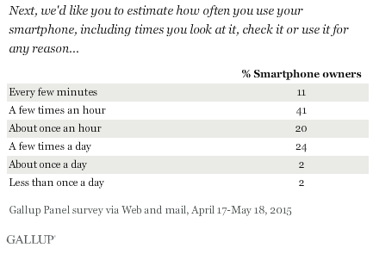and 44% of these same people have used their mobile phones to “look up real estate listings or info about a place to live” (Smith, Pew Research Center). This would suggest that the answer to the question about what the “physical environment” should be is a very simple one. The answer is this: every environment. Adults use their phones practically everywhere they go, which means that the app should be prepared to handle each and every environment. The user should be able to provide concise, important information on demand. It should find a way to give the user information such as the price, size, age, location, and images of the house in a simple way that the user can absorb no matter what situation that they are in.

***Target Platforms***

The platforms that the app will be available on is an important decision. As of August 2015, approximately 95.8% of smartphones run two Operating Systems — Android and Apple iOS, with Android running on 51.7% of devices, and iOS running on 44.1% of devices. (Statista) Many cross-platform development tools do not support Windows or Blackberry platforms, which means that the apps would have to be developed in their native environments. This would significantly increase the development time and subsequently the cost of development. Because Pensacola is a relatively small market, it would simply not be worth the time or the effort to develop the Old South House Finder application for the 4.2% of the App market that is Windows and Blackberry. For those reasons, this app will be developed strictly for Android and iOS platforms.

Value Proposition - Benefits

Old South House Finder is a progressive app that will take Old South Properties’ business to the next level. The app will be beneficial for several reasons. It will provide on the go access to resources, empowerment to its users through home show scheduler, and a reduction in negative opportunity cost caused by busy people.

***On the Go Access***

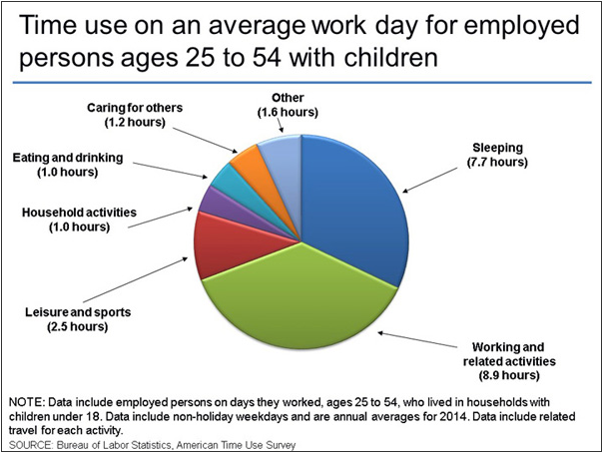 Everything in the Smart Phone world today is instant. Rather than simply appreciating convenience, people expect it. And a strong case could be made as to the reason why. According to the Bureau of Labor Statistics, the average American only has approximately 1.6 hours of unallocated time per day (Bureau of Labor Statistics). This means that people need a way to get information on demand without the need to be sitting down at a computer. With Old South House Finder, customers will be able to browse through housing options and schedule appointments with agents while they are on their lunch break or a short coffee break at work, or even laying in their bed, unwinding at the end of the day. This quote from Suzanne Kearns in her article entitled “Should You Develop a Mobile App for your Small Business?” nicely sums up the importance of having small businesses or real estate companies having a mobile presence:

"Being where your customers are is critical, and a recent [analysis](http://www.flurry.com/blog/flurry-insights/mobile-television-we-interrupt-broadcast-again#.VLWabtLF81J) by Flurry shows that people spend more time on their mobile devices than they do watching TV. Allowing customers and prospects to interact with your company from mobile devices is now mandatory. Having your company live on your customer's phones and engaging your customers with Push and SMS technology can quickly distance you from your competition and build loyalty. The easier it is to interact, the more business you will generate."

In other words, convenient, on-the-go access is vital to growth and competition in today’s marketplace (Kearns, Intuit Quick Books)

***Empowerment to Users through the Home Show Scheduler***

“Most Americans prefer to schedule personal appointments by using mobile applications, email, text messaging or Web sites, a Google Consumer Survey shows, reflecting the increasing use of mobile in daily activities,” writes Michael Barris of Mobile Commerce Daily (Barris, Mobile Commerce Daily). Many people do not want to take the time out of their busy day to call a representative and go through the process of scheduling an appointment. The Home Show Scheduler would give the user the ability to schedule a home show appointment. That appointment would then automatically be set as an event in their phone calendar as well as their Old South App. People want to feel like they have control over their schedule and their life through their technology. Jamie Turner, co-author of Go Mobile and CEO of Atlanta-based 60 Second Communications, backs this up by saying, “Your smartphone isn’t really a phone anymore — it’s more like a remote control for your life (Barris, Mobile Commerce Daily).”

***Reduction in Negative Opportunity Cost***

Opportunity cost flies under the radar of important financial losses all too often. Sometimes the opportunities we miss are more expensive than the threats we mitigate. The Old South House Finder app mitigates opportunity cost by both creating greater awareness through the mobile community, and allowing users to schedule appointments with an agent when they might otherwise have not had time. President of PencilAppoint.com, Mickey Macedo had this to say about mobile scheduling: “It’s a win-win for both businesses and consumers because it allows the businesses to cash in on an inventory of otherwise unused appointments (Barris, Mobile Commerce Daily).” In reference to mobile scheduling playing a large role in the future, Mr. Macedo said, “We think that going forward, people will want to control their appointments more and more through mobile devices (Barris, Mobile Commerce Daily).” Mobile scheduling is without a doubt one of the most powerful tools for mitigating opportunity cost. For that reason, its incorporation into the Old South App Finder brings a whole new level of business to Old South Properties.

Value Proposition – Risks

There is some level of risk in undertaking any business project. While the one risk to any business in undertaking a major project is usually financial ROI (Return on Investment), there are underlying factors that help to explain why that may be the case. We will analyze the ROI in a different section of this proposition. Two factors that could lead to a smaller ROI are the possibility of missed appointments, and the neglect to create awareness for the existence of the app. Here we analyze those risks and discuss how to mitigate them.

***Potential for Missed Appointments:***

One aspect of the app that does pose a potential concern is the Home Show Scheduler. It would be very easy for a person to schedule an appointment while in a hurry and subsequently forget that they scheduled it. Two different things can be done to mitigate that risk. One, will be taken care of by the app, and the other will be the responsibility of the agent to take care of. The app will provide a means for sending a notification reminder to the phone of the customer. This should work well as a primary reminder source, but a secondary would be helpful as well. This is where the agent comes in. The agent should simply call and confirm each appointment in order to ensure that the customer did indeed intend to set an appointment for that particular time and place and with that agent. Again, risk can be very easily mitigated, and should not be much of a cause for concern as the next potential issue.

***Neglect to Create App Awareness***

A good app that nobody knows about is a useless app. A proper plan of advertisement should be put forth by Old South’s Marketing department in order to mitigate this risk. It would be good to start advertising for the app on the company website and on property signs approximately a week before the app is released. Again, failure to address this potential risk would mean nobody could get their hands on the app. With this being said, once users do get their hands on the app, Old South should see a marked increase in appointments being scheduled.

Value Proposition - Competitors

There have been a few very successful competitor apps that reside in the same market as the Old South House Finder app would reside. These realty apps are worldwide, rather than regional like Old South. The three main competitor apps are as follows: Zillow, Trulia, and Realtor.com.

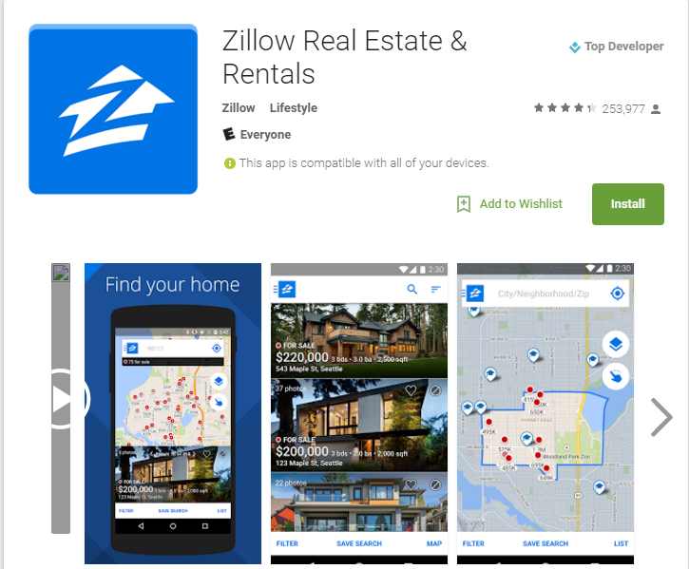**Zillow**

Having between somewhere between 10,000,000 and 50,000,000 downloads on the Google Play Store, Zillow comes in as the top Real Estate app currently on the market. (Google Play) Zillow is described by Melanie Haselmayr of Forbes as being “*a multi-use platform, mainly used for property search. With a number of robust search filters and extra features (mortgage calculators, access to “hidden” inventory, property estimates), the site offers a good overview of the real estate market and available properties. Many listings include MLS numbers in order to facilitate your search* (Haselmayr, Forbes).”Because of the success of Zillow, many of the examples used in this proposition will be modeled similarly to the Zillow app.

**Trulia**

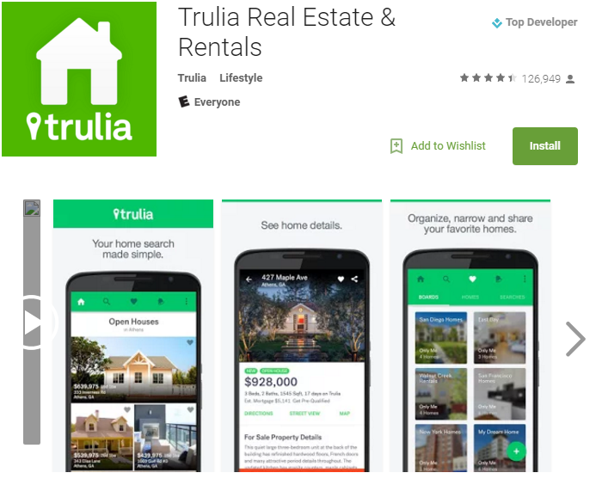Again, similar to Zillow, Trulia is a highly successful app with somewhere between 5,000,000 and 10,000,000 downloads on the Google Play Store. Best Android Apps Review on the Google Play Store describes Trulia by calling it, “One of the best Android apps for finding a house to buy, place to rent, or to simply browse local real estate information.”

**Realtor.com**

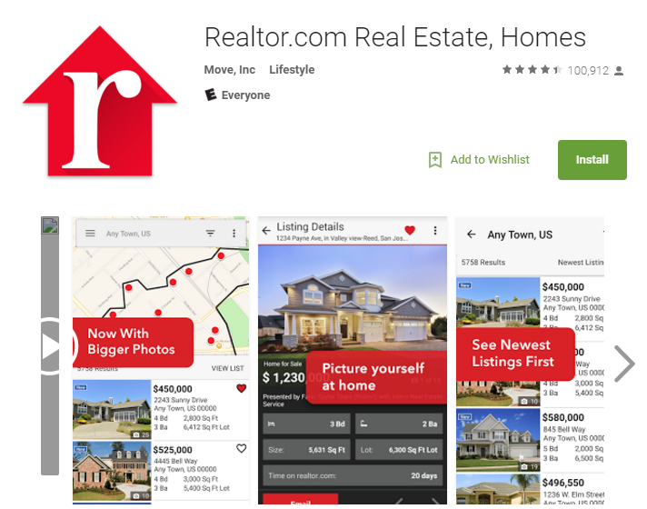 The Realtor.com app comes in around the same amount of Google Play Store downloads as the Trulia app at approximately 5,000,000 – 10,000,000 downloads. The Realtor.com app seems to be built primarily around housing information specifically in the area, and seems to have a lot of features supporting localized house searches.

Application Description

The Old South House Finder app will include many features that will be vital to the increased success in revenues for the company. The app features and descriptions of what they do are listed below:

**House Filter**

The house filter allows users to narrow down their search based on different search criteria in order to see a list of items that only relate to houses that are within their specifications. The criteria that can be filtered through will be as follows: Price, Location, School District, Age, Size, Floorplans, Land, and Neighborhood. Below is a visual representation of this portion of the app:

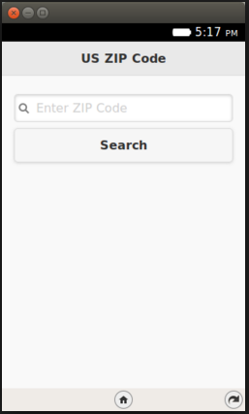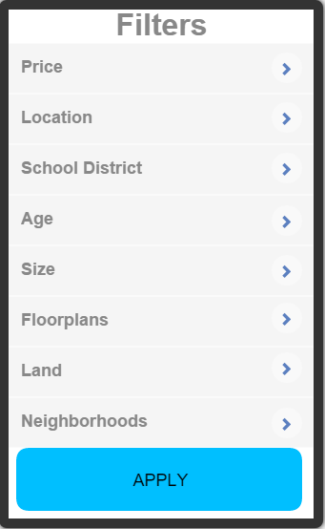

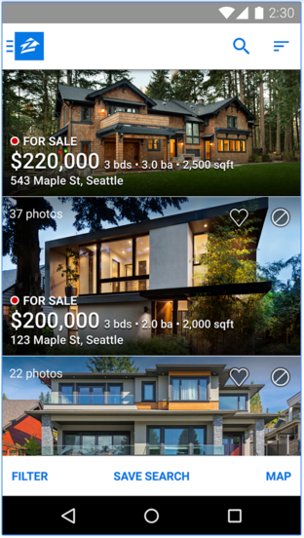**House Browser**

Once the filters have been set, the user will then be able to seamlessly browse through houses that match their criteria. Much like browsing through Facebook and looking at posts. The most important, relevant information will be concisely displayed on each house listing. The app would look very similar to this house browsing feature in this Zillow app:

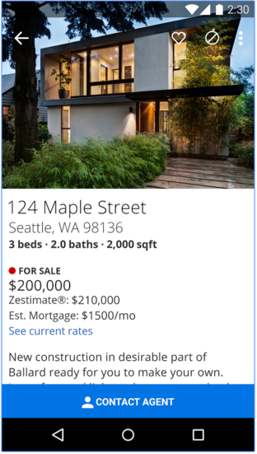**House Viewer**

Once the user finds a house that they like as they are scrolling through the houses that match their search, they can click on that house and view information about that particular house. This view will give a much more detailed information on the house, and will allow the user to also directly schedule a home showing for that particular house with an agent. This portion of the app would look very similar to this app (also from Zillow).

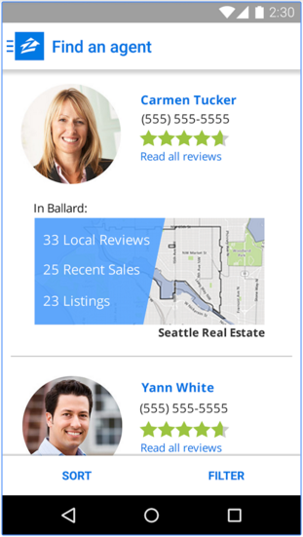**Agent Finder**

While the House Show Scheduler feature will allow to instantly set up an appointment with the agent in charge of that specific house, a user could also simply scroll through agents in their area, select an agent, and contact that agent based off of contact information provided. This feature would look similar to this:

Financial Overview

***Cost Enumerated***

So, exactly how much will it cost to develop an application with a treasure trove of features like Old South House Finder has? There are several factors involved in answering this question. The first factor involved is the cost of personnel which largely depends on the time required to develop the app. The second cost involved has to do with the cost of development outside of personnel such as the systems needed and the cost of publishing the application. We will examine the cost of each of these. Research will tell you that the average application development can range anywhere from $5,000-$200,000. That is a huge range! What we will do is break down the source of each cost and ultimately present the final cost of getting the app initially launched.

**Personnel Cost**

According to Mark Stetler, the CEO of App Muse, considered to be the “internet’s leading provider of free app development quotes from experienced, pre-screened app developers,” “the average cost of an experienced, reputable US-based developer is **$100-120/hr**, and the average project takes between 60 and 80 hours.”(Stetler, App Muse) Further study will tell you that costs in the $100s per hour are general only found in more tech savvy areas such as San Francisco, CA. According to App Consultant, Mark Robinson, app development is “**$90-160/hr** in the San Francisco, CA area, where as app development in the Atlanta, GA area is much lower at **$55-60/hr**” (Robinson). We will personally charge **$58/hr** for development of the Old South House Finder app.

Since this application will be charged by the hour, the next step is determining the cost required for development. According to ImpigerMobile.com, an “application with list based/organized static data with server side interaction” would take “4-8 weeks to develop.” (Impiger Mobile) Because there will be a small amount of server interaction with users setting appointments, the Old South House Finder app will take approximately six weeks (each 40 hours) or 240 total hours to complete with a one man development team. If the app needs to be done earlier, it will require more developers, and there will be a small 5% increase in the hourly cost per developer added to the team. That would result in a cost table that looks like this: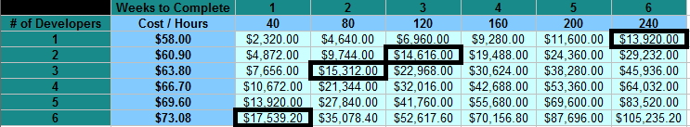

***Note: Prices in bold are the possible costs for development of this app given it will take a total of 240 man hours to complete.***

Assuming the company is willing to wait for the full six weeks to have the app developed by a solo developer, the app will cost **$13,920** for labor.

**Additional Costs to Consider:**

If Old South Properties does not currently own a server for their website that they have running, they will likely need to purchase a server that can handle the necessary transactions of the application. A good server to use would be the Dell PowerEdge T110 II Tower Server, which would cost approximately **$859**. (Dell)

If the company does not yet hold an iOS license for publishing on the Apple App Store, or an Android license in order to publish on the Google Play Store, that will be a cost that will have to be considered as well. The cost of an Apple license is **$99/yr** and the cost of a Google license is a one-time fee of **$25.**

**Summary**

|  |
| --- |
| Cost of Labor: $13,920 + |
| Cost of Server: $859 + |
| Cost to Publish: $124 + |
| Total Possible Cost: $14,903 |

Financial Overview - Revenues

The second set of big questions are, “What would it take in order to receive a Return on Investment for Old South Properties?” and how long should it take to receive a return on investment? Those are both good questions, and this section of the proposition will attempt to answer them.

According to Michele Lerner of Realtor.com, a typical realtor receives a 6% commission on the sale of a house (Lerner, Realtor.com). According to Mark Ferguson of InvestFourMore.com, in reference to the split between the Realtor and Real Estate Company, “the split is 70% to the agent and 30% to the broker (Ferguson, InvestFourMore.com).” According to statistics by Trulia, the Median sale price of a house in the Pensacola are is $120,500 (Trulia). With these statistics in mind, we can come to the conclusion that if a house were sold at the median price, Old South properties would receive **$2,169** on the sale. This means that it would take approximately **7** house sales in order to receive an initial return on investment.

Since, according to Trulia, the average realtor sells about **35** homes per year, if just **10** of Old South’s agents hit the average before the app was developed, and we assumed a **30%** increase in houses sold due to the app, we would be looking at a Return on Investment of approximately **$212,842** in the first year alone.

So is this good? What should the time table for Return of Investment on an app be? According to Suzanne Kearns of QuickBooks.com, “if the cost of creating the app is recovered in one year or less, than it’s probably a good investment (Kearns, QuickBooks.com).” So yes, even if the increase in sales wasn’t anywhere near 30%, Old South would easily receive a Return on their investment well within a year. The opportunity is simply too good to pass up.

What’s Next?

So what should Old South do in order to get started with this project? There are a few things that will be necessary in order for this project to get off of the ground: meet to decide details about the application, put together necessary information, and start advertising!

First, a general meeting to establish some ground rules for general application design will be necessary. In this meeting, we will decide what color schemes we will want to use, as well as how we want the application to flow. We will discuss which features we want to keep, and which features we think are unnecessary or ambiguous. We will also discuss time restraints for development at this meeting.

Next, the company will need to provide our development team with necessary information to get the app off the ground. We will need contact information for agents, as well as general information about properties owned by Old South so that we can populate the app.

Once the information is compiled, and development begins, Old South should start designing advertisements in order to have the market primed and ready once the app has been released. Good methods of advertisement would be on the Old South website, on property signs, on Old South billboards, and on Agent business cards. Once the app has been released, the advertisements should also be released, and old south can watch the increase in appointments begin to roll in, and the profits begin to rise! Old South will be able to proudly take a step into the future of business.

**Bibliography**

1. Smith, Aaron. Pew Research Center. "U.S. Smartphone Use in 2015." Accessed November 17, 2015. http://www.pewinternet.org/2015/04/01/us-smartphone-use-in-2015/.

2. Pew Research Center. "Mobile Technology Fact Sheet." Accessed November 17, 2015. http://www.pewinternet.org/fact-sheets/mobile-technology-fact-sheet/.

3. Zip Atlas. "Average Population Age in Florida by City." Accessed November 17, 2015. http://zipatlas.com/us/fl/city-comparison/median-age.4.htm.

4. Newport, Frank. "Most U.S. Smartphone Owners Check Phone at Least Hourly." Gallup. Accessed November 17, 2015. http://www.gallup.com/poll/184046/smartphone-owners-check-phone-least-hourly.aspx.

5. Statista. "Market share held by smartphone platforms in the United States from January 2012 to August 2015." Accessed November 17, 2015. http://www.statista.com/statistics/266572/market-share-held-by-smartphone-platforms-in-the-united-states/.

6. Bureau of Labor Statistics. "American Time Use Survey." Accessed November 17, 2015. http://www.bls.gov/tus/charts/.

7. Kearns, Suzanne. "Should You Develop a Mobile App for Your Small Business?." Intuit Quick Books. Accessed November 17, 2015. http://quickbooks.intuit.com/r/mobile-and-apps/should-you-develop-a-mobile-app-for-your-small-business.

8. Barris, Michael. "How mobile appointments translate into customer satisfaction, higher conversions." Mobile Commerce Daily. Accessed November 17, 2015. http://www.mobilecommercedaily.com/mobile-appointment-calendars-rule-the-day-and-month-and-year-study.

9. Haselmayr, Melanie. "10 Best Apps For Real Estate Agents And Brokers." Forbes. Accessed November 17, 2015. http://www.forbes.com/sites/allbusiness/2014/06/24/10-best-apps-for-real-estate-agents-and-brokers/.

10. Google Play Store. "Trulia." Accessed November 17, 2015. https://play.google.com/store/apps/details?id=com.trulia.android&hl=en.

11. Stetler, Mark. "How Much Will My Business App Cost?." App Muse. Accessed November 17, 2015. http://appmuse.com/appmusing/how-much-will-my-business-app-cost/.

12. Impiger Mobile. "How Much Time does it take to Develop an iPhone App?." Accessed November 17, 2015. http://www.impigermobile.com/how-much-time-does-it-take-to-develop-an-iphone-app/.

13. Lerner, Michele. "How Do Real Estate Agents Get Paid?." Realtor.com. Accessed November 17, 2015. http://www.realtor.com/advice/sell/how-do-real-estate-agents-get-paid/.

14. Ferguson, Mark. "How Much Money Do Real Estate Agents Make?." Realtor.com. Accessed November 17, 2015. http://investfourmore.com/2013/11/much-money-real-estate-agents-make/.

15. Trulia. "On average, how many homes does the average, run-of-the-mill realtor in SE Florida sell per year?." Accessed November 17, 2015. http://www.trulia.com/voices/Home_Buying/On_average_how_many_homes_does_the_average_run_o-547880.

16. Dell. "PowerEdge T110 II Tower Server." Accessed November 17, 2015. http://www.dell.com/us/business/p/poweredge-t110-2/pd?oc=bect12bfsi&model_id=poweredge-t110-2&l=en&s=bsd.